# Product line by revenue

Product line

0

K

5

K

K

10

K

15

K

20

K

25

K

30

35

K

K

40

45

K

50

K

55

K

60

K

T

o

t

a

l

54,338

54,306

56,145

49,194

53,862

55,123

Product line

Electronic accessories

Fashion accessories

Food and beverages

Health and beauty

Home and lifestyle

Sports and travel

Electr..Fashio..Food a..Health..Home ..Sports..

Sum of Total for each Product line. Color shows details about Product line. The marks are labeled by sum of Total.

# payment types by sales

Payment Cash

100,767

109,993

Ewallet

112,207

Cash

Credit card

Ewallet

Credit card

Sum of Total and Payment. Color shows details about Payment. The marks are labeled by sum of Total and Payment.

# payment types by sales

Payment Cash

Credit card

Ewallet

Sum of Total and Payment. Color shows details about Payment. The marks are labeled by sum of Total and Payment.

# Sales across cities by product line

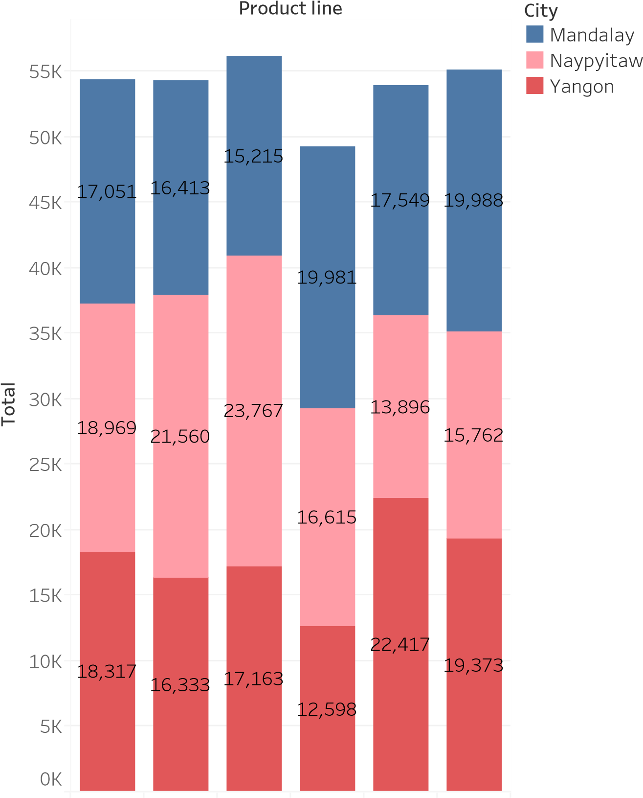

Electr..Fashio..Food a..Health..Home ..Sports..

Sum of Total for each Product line. Color shows details about City. The marks are labeled by sum of Total.

## Weekday wise by sales

Weekday

K

0

K

5

10

K

15

K

20

K

25

K

30

K

35

K

K

40

45

K

50

K

55

K

T

o

t

a

l



45,349

44,458

56,121

43,926

43,731

37,899

51,482

Weekday

Sunday

Monday

Tuesday

Wednesday

Thursday

Friday

Saturday

SundayMondayTuesdayWedne..Thursd..FridaySaturd..

The trend of sum of Total for Weekday. Color shows details about Weekday. The marks are labeled by sum of Total.

# Productline by revenue

Product line

Sports and travel

55,123

Home and lifestyle

53,862

Health and beauty

49,194

Food and beverages

56,145

Fashion accessories

54,306

Electronic accessories

54,338

Electronic accessories

Fashion accessories

Food and beverages

Health and beauty

Home and lifestyle

Sports and travel

Product line and sum of Total. Color shows details about Product line. Size shows sum of Total.

The marks are labeled by Product line and sum of Total.